Analysis of Building Frames (Using Kani’s Method)
Gasper Kani, a German engineer, developed another distribution procedure based on slope deflection equations. This method is very useful for the analysis of multistorey frames. The greatest advantage of this method is, even if a mistake is committed in distribution in one of the cycles, it converges finally to the correct answer. Even today, many practising engineers who are not familiar with computer methods, use Kani's method for the analysis of 3 to 4 storey building frames.
This method is first explained for structures with fixed ends. Then, the modifications to handle simply supported and overhanging ends are discussed. Analysis of symmetric frames making use of the symmetry is also explained, after which an analysis of general frames is taken up.
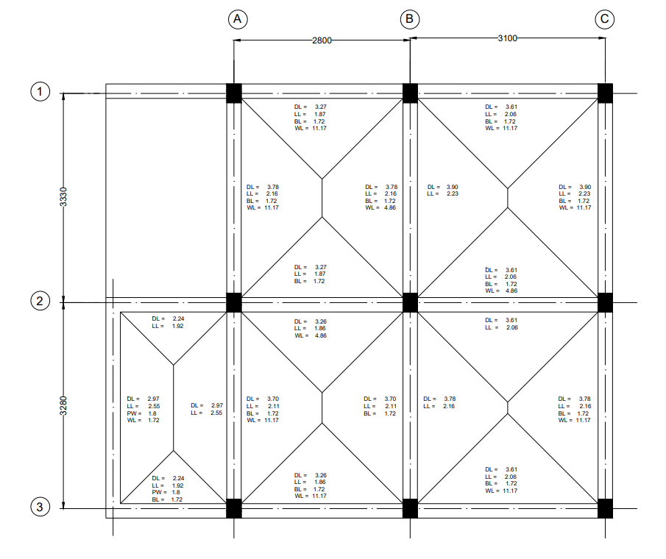
Figure 1: Beam Layout
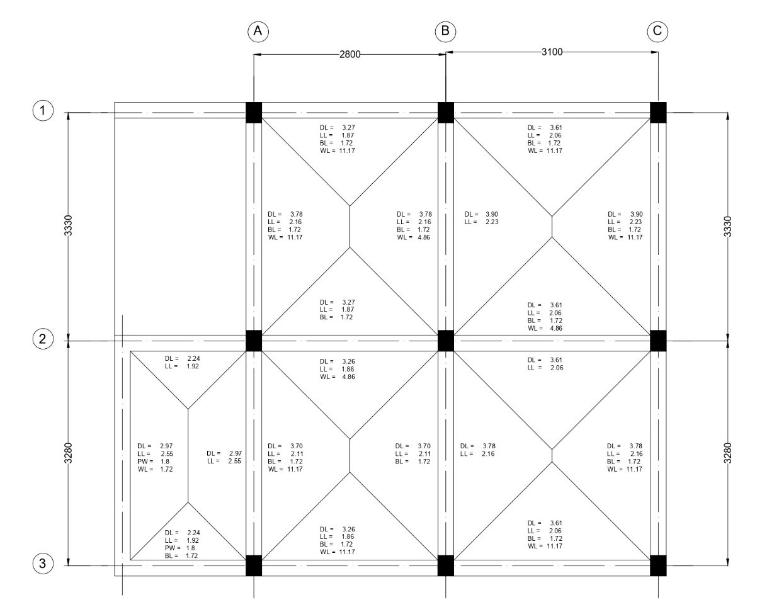
Figure 2: Frames.

Analysis of Frame A1-B1-C1

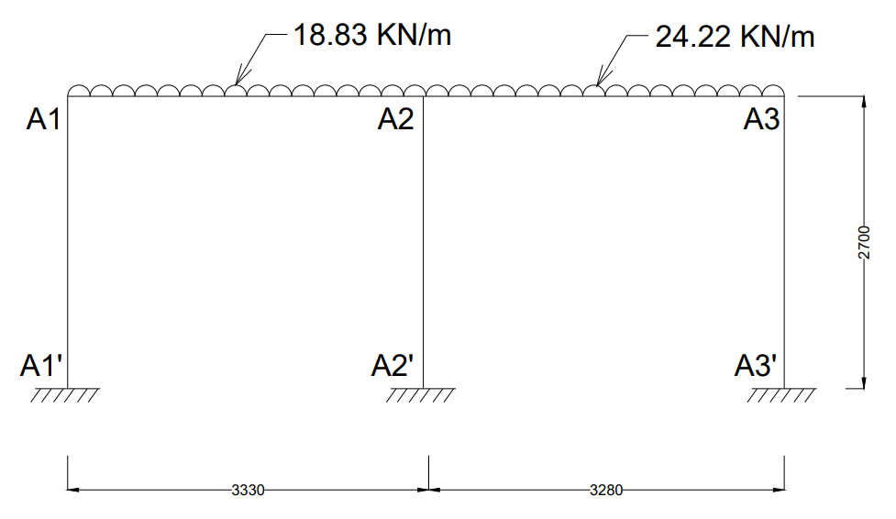
Step 1: Fixed End Moments
MF_{A1A2} = $\frac{-{WL}^{2}}{12}$ = $\frac{-18.83 × {3.33}^{2}}{12}$ = -17.40 KN-m
MF_{A2A1} = $\frac{{WL}^{2}}{12}$ = $\frac{18.83 × {3.33}^{2}}{12}$ = +17.40 KN-m
MF_{A2A3} = $\frac{-{WL}^{2}}{12}$ = $\frac{-24.22 × {3.28}^{2}}{12}$ = -21.71 KN-m
MF_{A3A2} = $\frac{{WL}^{2}}{12}$ = $\frac{24.22 × {3.28}^{2}}{12}$ = +21.71 KN-m
Fixed end moments in All the columns are zero.
i.e,
MF_{A1A1՛ =} MF_{A1՛A1} = MF_{A2A2՛ =} MF_{A2՛A2 =} MF_{A3A3՛ =} MF_{A3՛A3} = 0

Step 2: Rotation Factor $\left(R.F = -\frac{1}{2} \left(\frac{k}{Σk}\right) \right)$, $\left(k= \frac{4EI}{L}\right)$
Joints | Members | Stiffness ($k$) | $$Σk$$ | R.F
A1 | A1A2 | 1.201EI | 2.682EI | -0.224
A1 | A1A1՛ | 1.481EI | 2.682EI | -0.276
A2 | A2A1 | 1.201EI | 3.902EI | -0.154
A2 | A2A3 | 1.220EI | 3.902EI | -0.156
A2 | A2A2՛ | 1.481EI | 3.902EI | -0.190
A3 | A3A2 | 1.220EI | 2.701EI | -0.226
A3 | A3A3՛ | 1.481EI | 2.701EI | -0.274

Stiffness ($k$) $\left(k=\left(\frac{4EI}{L}\right)\right)$
K_{A1A2} = $\left(\frac{4EI}{3.33}\right)$ = 1.201EI
K_{A1A1՛} = $\left(\frac{4EI}{2.7}\right)$ = 1.481EI
K_{A2A1} = $\left(\frac{4EI}{3.33}\right)$ = 1.201EI
K_{A2A3} = $\left(\frac{4EI}{3.28}\right)$ = 1.220EI
K_{A2A2՛} = $\left(\frac{4EI}{2.7}\right)$ = 1.481EI
K_{A3A2} = $\left(\frac{4EI}{3.28}\right)$ = 1.220EI
K_{A3A3՛} = $\left(\frac{4EI}{2.7}\right)$ = 1.481EI
Sum of Stiffness ∑$k$ at Joints
A1: 1.201EI + 1.481EI = 2.682EI
A2: 1.201EI + 1.220EI + 1.481EI = 3.902EI
A3: 1.220EI + 1.481EI = 2.701EI
Rotation Factor $\left(R.F = -\frac{1}{2} \left(\frac{k}{Σk}\right) \right)$
R.F_{A1A2} = $-\frac{1}{2} \left(\frac{1.201}{2.682EI}\right)$ = -0.224
R.F_{A1A1՛} = $-\frac{1}{2} \left(\frac{1.481EI}{2.682EI}\right)$= -0.276
R.F_{A2A1} = $-\frac{1}{2} \left(\frac{1.201EI}{3.902EI}\right)$ = -0.154
R.F_{A2A3} = $-\frac{1}{2} \left(\frac{1.220EI}{3.902EI}\right)$ = -0.156
R.F_{A2A2՛} = $-\frac{1}{2} \left(\frac{1.481EI}{3.902EI}\right)$ = -0.190
R.F_{A3A2} = $-\frac{1}{2} \left(\frac{1.220EI}{2.701EI}\right)$ = -0.226
R.F_{A3A3՛} = $-\frac{1}{2} \left(\frac{1.481EI}{2.701EI}\right)$ = -0.274

Step 3: Displacement Factor $\left(D.F = -\frac{3}{2} \left(\frac{k}{Σk}\right) \right)$
Storey | Members | $$k$$ | $$Σk$$ | D.F
1 | A1A1՛ | 1.481EI | 4.444EI | -0.5
1 | A2A2՛ | 1.481EI | 4.444EI | -0.5
1 | A3A3՛ | 1.481EI | 4.444EI | -0.5

Stiffness ($k$) $\left(k=\left(\frac{4EI}{L}\right)\right)$
K_{A1A1՛} = $\left(\frac{4EI}{2.7}\right)$ = 1.481EI
K_{A2A2՛} = $\left(\frac{4EI}{2.7}\right)$ = 1.481EI
K_{A3A3՛} = $\left(\frac{4EI}{2.7}\right)$ = 1.481EI
Sum of Stiffness ∑$k$ at Storey
∑$k$ = 1.481EI + 1.481EI + 1.481EI = 4.444EI
Displacement Factor $\left(D.F = -\frac{3}{2} \left(\frac{k}{Σk}\right) \right)$
D.F_{A1A1՛} = $-\frac{3}{2} \left(\frac{1.481EI}{4.444EI}\right)$= -0.5
D.F_{A2A2՛} = $-\frac{3}{2} \left(\frac{1.481EI}{4.444EI}\right)$ = -0.5
D.F_{A3A3՛} = $-\frac{3}{2} \left(\frac{1.481EI}{4.444EI}\right)$ = -0.5

Rotation and Displacement Contribution

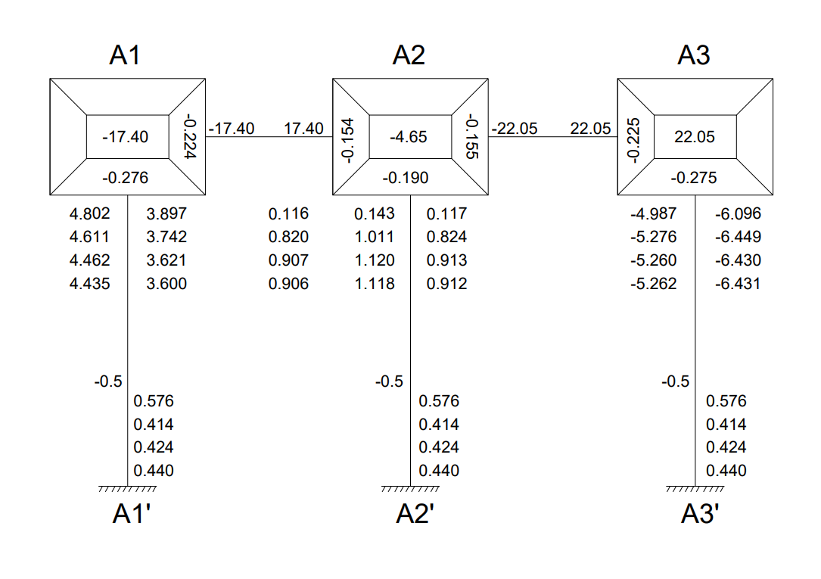
Cycle 1
Joint Rotation $\left(C.V. = R.F × \left[∑FEM+NCV+FCV\right]\right)$
M_{A1A2} = -0.224 × [-17.40 + 0 + 0] = 3.897
M_{A1A1՛} = -0.276 × [-17.40 + 0 + 0] = 4.802
M_{A2A1} = -0.154 × [-4.31 + 3.897 + 0] = 0.064
M_{A2A3} = -0.156 × [-4.31 + 3.897 + 0] = 0.064
M_{A2A2՛} = -0.190 × [-4.31 + 3.897 + 0] = 0.078
M_{A3A2} = -0.226 × [21.71+ 0.064 + 0] = -4.920
M_{A3A3՛} = -0.274 × [21.71 + 0.064 + 0] = -5.966
Displacement Contribution
For All Columns $\left(R.V. = D.F × \left[∑Rotations Contribution at Columns\right]\right)$
M_{A1A1՛} = M_{A2A2՛} = M_{A3A3՛} = -0.5 $×$ (4.802 + 0.078 + (-5.966)) = 0.543

Cycle 2
Joint Rotation $\left(C.V. = R.F × \left[∑FEM+NCV+FCV\right]\right)$
M_{A1A2} = -0.224 × [-17.40 + 0.543 + 0.064] = 3.761
M_{A1A1՛} = -0.276 × [-17.40 + 0.543 + 0.064] = 4.635
M_{A2A1} = -0.154 × [-4.31 + 0.543 + 3.761 + (-4.920)] = 0.759
M_{A2A3} = -0.156 × [-4.31 + 0.543 + 3.761 + (-4.920)] = 0.768
M_{A2A2՛} = -0.190 × [-4.31 + 0.543 + 3.761 + (-4.920)] = 0.936
M_{A3A2} = -0.226 × [21.71 + 0.543 + 0.764] = -5.202
M_{A3A3՛} = -0.274 × [21.71 + 0.543 + 0.764] = -6.307
Displacement Contribution
For All Columns $\left(R.V. = D.F × \left[∑Rotations Contribution at Columns\right]\right)$
M_{A1A1՛} = M_{A2A2՛} = M_{A3A3՛} = -0.5 $×$ (4.635 + 0.936 + (-6.307)) = 0.368

Cycle 3
Joint Rotation $\left(C.V. = R.F × \left[∑FEM+NCV+FCV\right]\right)$
M_{A1A2} = -0.224 × [-17.40 + 0.368 + 0.759] = 3.645
M_{A1A1՛} = -0.276 × [-17.40 + 0.368 + 0.759] = 4.491
M_{A2A1} = -0.154 × [-4.31 + 0.368 + 3.645 + (-5.202)] = 0.847
M_{A2A3} = -0.156 × [-4.31 + 0.368 + 3.645 + (-5.202)] = 0.858
M_{A2A2՛} = -0.190 × [-4.31 + 0.368 + 3.645 + (-5.202)] = 1.044
M_{A3A2} = -0.226 × [21.71 + 0.368 + 0.858] = -5.183
M_{A3A3՛} = -0.274 × [21.71 + 0.368 + 0.858] = -6.285
Displacement Contribution
For All Columns $\left(R.V. = D.F × \left[∑Rotations Contribution at Columns\right]\right)$
M_{A1A1՛} = M_{A2A2՛} = M_{A3A3՛} = -0.5 $×$ (4.491 + 1.044 + (-6.285)) = 0.375

Cycle 4
Joint Rotation $\left(C.V. = R.F × \left[∑FEM+NCV+FCV\right]\right)$
M_{A1A2} = -0.224 × [-17.40 + 0.375 + 0.847] = 3.624
M_{A1A1՛} = -0.276 × [-17.40 + 0.375 + 0.847] = 4.465
M_{A2A1} = -0.154 × [-4.31 + 0.375 + 3.624 + (-5.183)] = 0.846
M_{A2A3} = -0.156 × [-4.31 + 0.375 + 3.624 + (-5.183)] = 0.857
M_{A2A2՛} = -0.190 × [-4.31 + 0.375 + 3.624 + (-5.183)] = 1.044
M_{A3A2} = -0.226 × [21.71 + 0.375 + 0.857] = -5.185
M_{A3A3՛} = -0.274 × [21.71 + 0.375 + 0.857] = -6.286
Displacement Contribution
For All Columns $\left(R.V. = D.F × \left[∑Rotations Contribution at Columns\right]\right)$
M_{A1A1՛} = M_{A2A2՛} = M_{A3A3՛} = -0.5 $×$ (4.435 + 1.118 + (-6.431)) = 0.389

Step 4: Final End Moments
M_{ij} = FEM + 2×M_{ij} (Near end Rotation) + M_{ji} (Far end Rotation) +M՛՛ (Displacement)
Beams (No Sway M՛՛= 0)
M_{A1A2} = -17.40 + 2(3.624) + 0.846 = -9.30
M_{A2A1} = 17.40 + 2(0.846) + 3.624 = 22.72
M_{A2A3} = -21.71 + 2(0.857) + (-5.185) = -25.18
M_{A3A2} = 21.71 + 2(-5.185) + 0.857 = 12.20
Column (With Sway M՛՛= 0.389)
M_{A1A1՛} = 0 + 2(4.465) + 0 + 0.389 = 9.32
M_{A1՛A1} = 0 + 2(0) + 4.465 + 0.389 = 4.85
M_{A2A2՛} = 0 + 2(1.044) + 0 + 0.389 = 2.48
M_{A2՛A2} = 0 + 2(0) + 1.044 + 0.389 = 1.43
M_{A3A3՛} = 0 + 2(-6.286) + 0 + 0.389 = -12.18
M_{A3՛A3} = 0 + 2(0) + (-6.286) + 0.389 = -5.90
Equilibrium Check
Joint A1 = M_{A1A2} + M_{A1A1՛} = -9.30 + 9.32 = 0.02 ≈ 0
Joint A2 = M_{A2A1} + M_{A2A3՛ +} M_{A2A2՛} = 22.72 + (-25.18) + 2.48 = 0.02 ≈ 0
Joint A3 = M_{A3A2} + M_{A3A3՛} = 12.20 – 12.18 = 0.02 ≈ 0
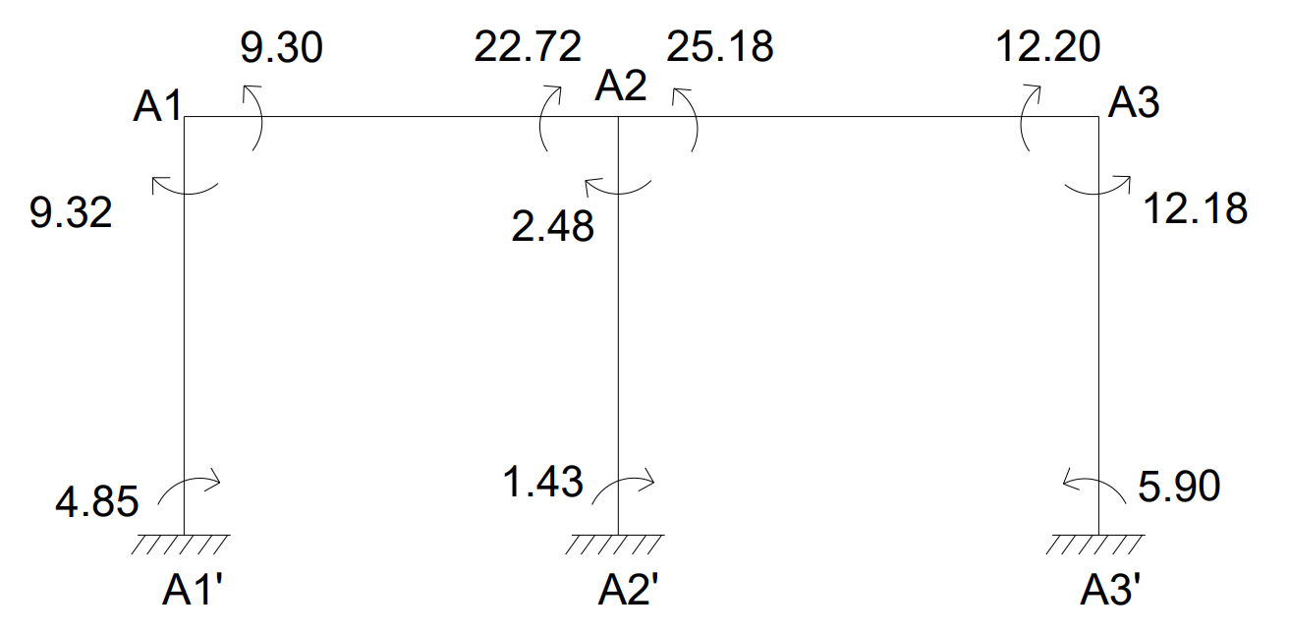

CALCULATION BENDING MOMENT
BM_{A1A2} = $\frac{{WL}^{2}}{8}$ = $\frac{{18.83 ×3.33}^{2}}{8}$ = 26.10KN-m
BM_{A2A3} = $\frac{{WL}^{2}}{8}$ = $\frac{{24.22 ×3.28}^{2}}{8}$ = 32.57KN-m
BENDING MOMENT DIAGRAM
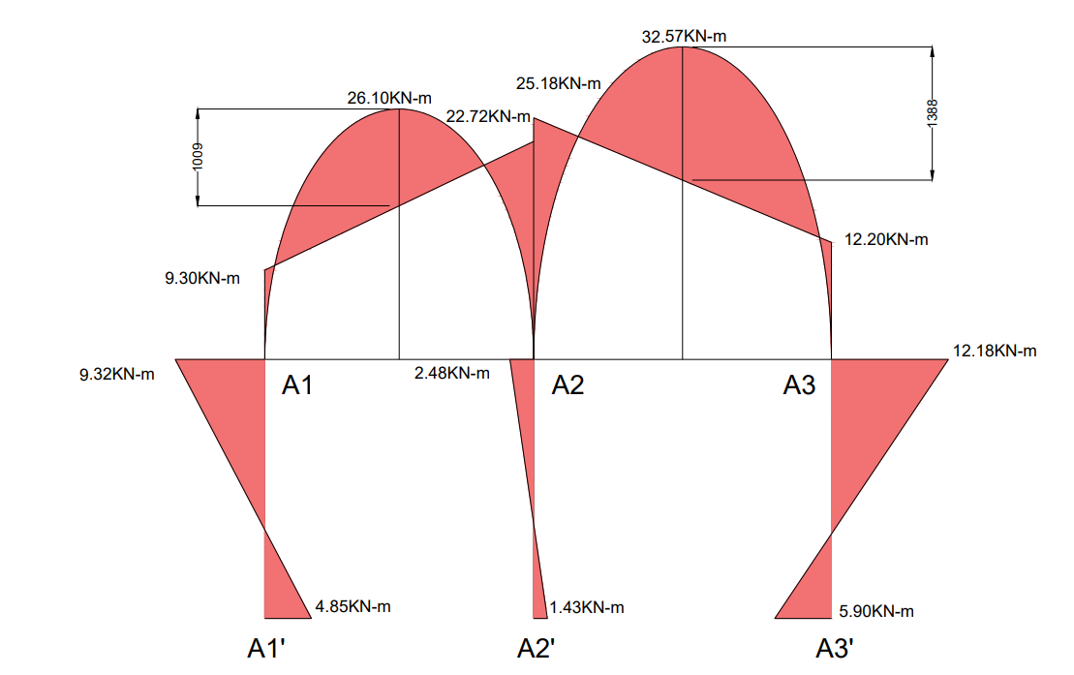
CALCULATION OF REACTIONS

SPAN A1-A2
Length (L) = 3.33m, UDL (W) = 18.83KN/m
Simply Supported Reactions:
R_{total} = $\frac{WL}{2}$ = $\frac{18.83 ×3.33}{2}$ = 31.35KN
Reaction Due to End Moments:
R_{moments} = $\frac{M_{A2A1}- M_{A1A2)}}{L}$ = $\frac{22.72 - 9.30}{3.33}$ = 4.03KN
Final Reactions:
R_{A1} = R_{total} – R_{moments} = 31.35 – 4.03 = 27.32KN
R_{A2(Left)} = R_{total} + R_{moments} = 31.35 + 4.03 = 35.38KN

SPAN A2-A3
Length (L) = 3.28m, UDL (W) = 24.22KN/m
Simply Supported Reactions:
R_{total} = $\frac{WL}{2}$ = $\frac{24.22 ×3.28}{2}$ = 39.72KN
Reaction Due to End Moments:
R_{moments} = $\frac{M_{A2A3}- M_{A3A2}}{L}$ = $\frac{25.18- 12.20}{3.28}$ = 3.95KN
Final Reactions:
R_{A2(Right)} = R_{total} + R_{moments} = 39.72 + 3.95 = 43.67KN
R_{A3}= R_{total} – R_{moments} = 39.72 – 3.95 = 35.77KN
Total Reactions:
Reaction at Column A1 (R_{A1}) = 27.32KN
Reaction at Column A2 (R_{A2}) = R_{A2(Left)} + R_{A2(Right)} = 35.38 + 43.67 = 79.05KN
Reaction at Column A3 (R_{A3}) = 35.77KN
